44 observation

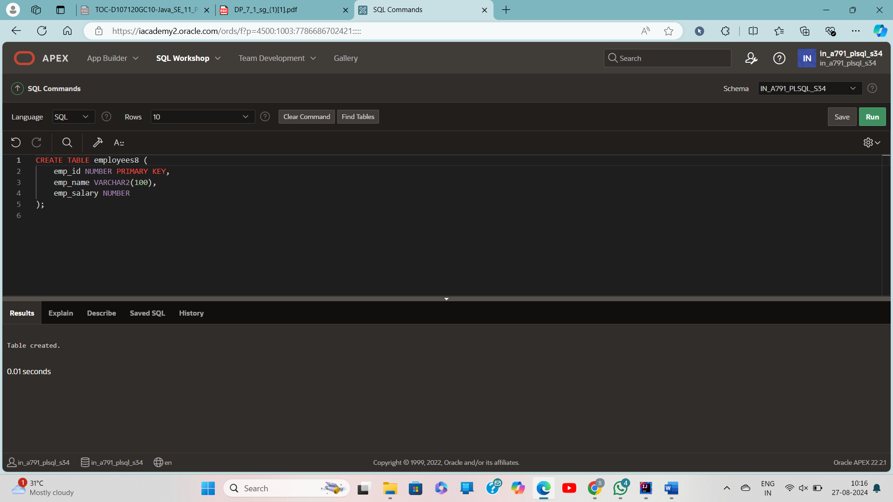

CREATE TABLE employees8 (

emp_id NUMBER PRIMARY KEY,

emp_name VARCHAR2(100),

emp_salary NUMBER

);

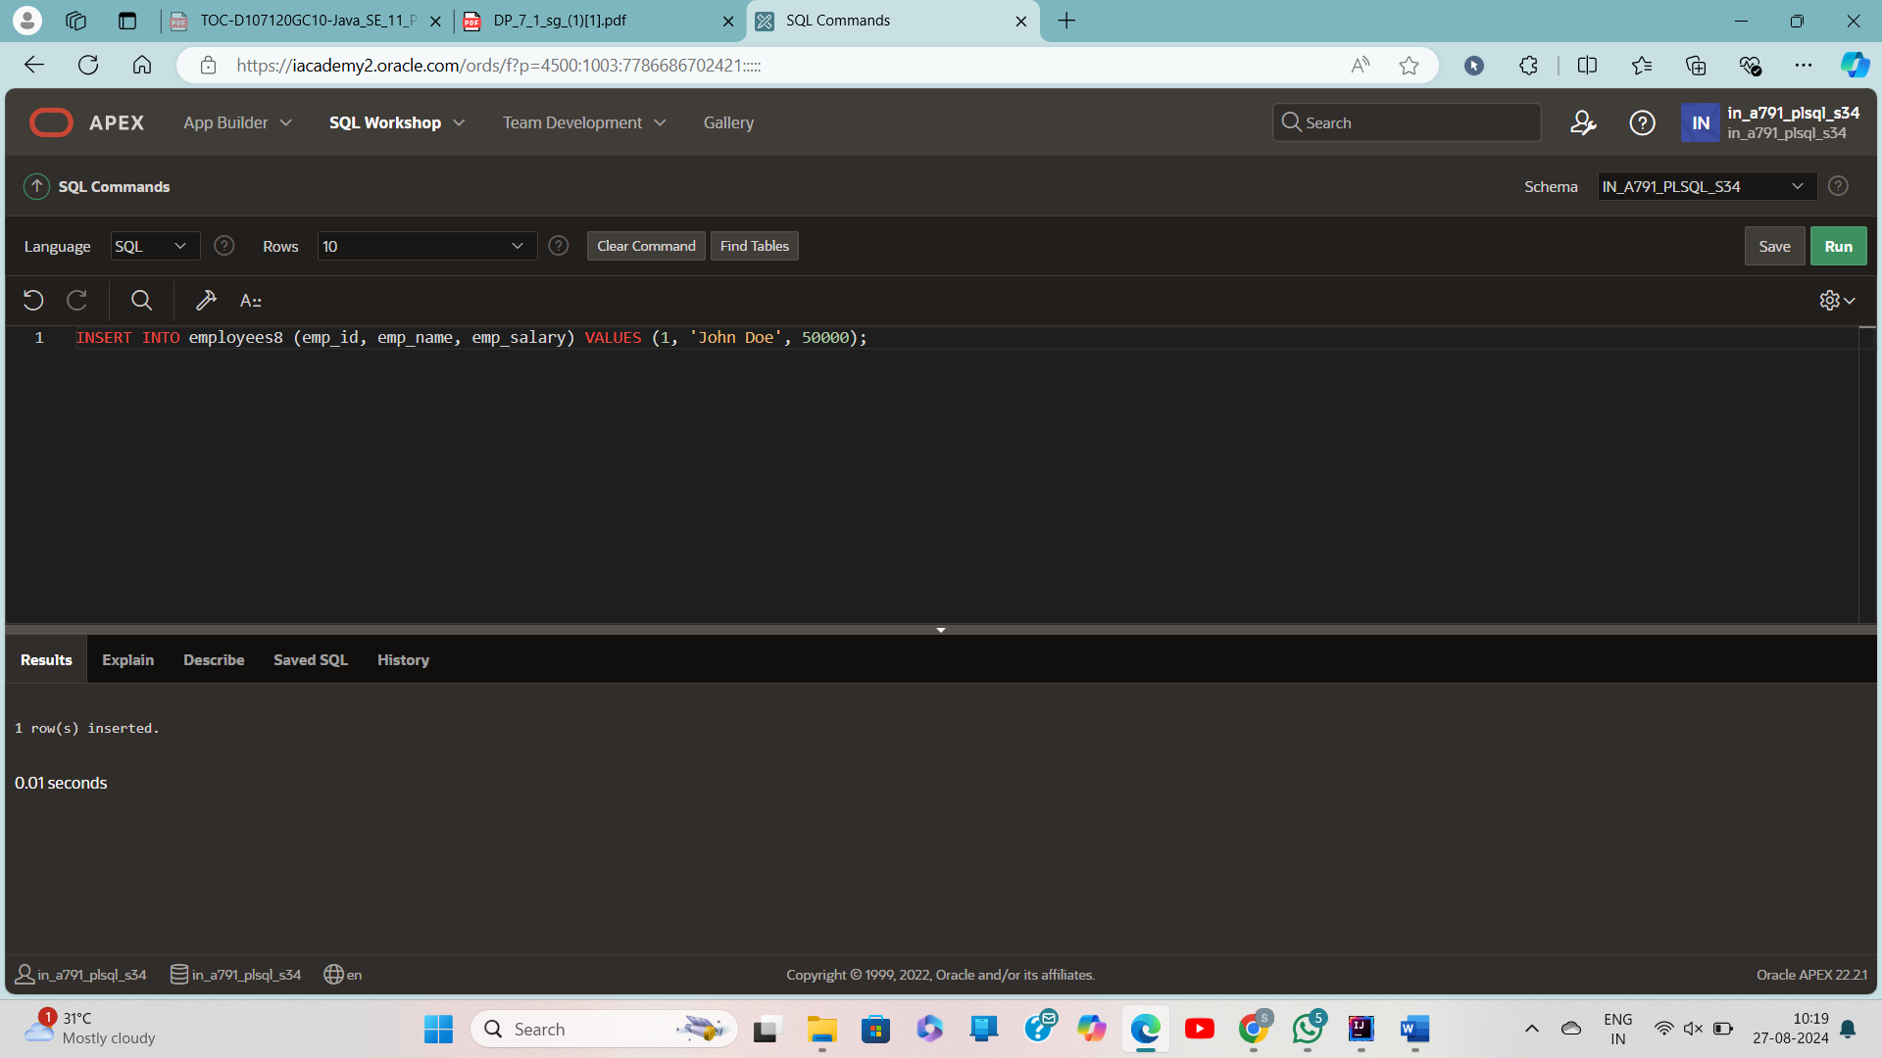

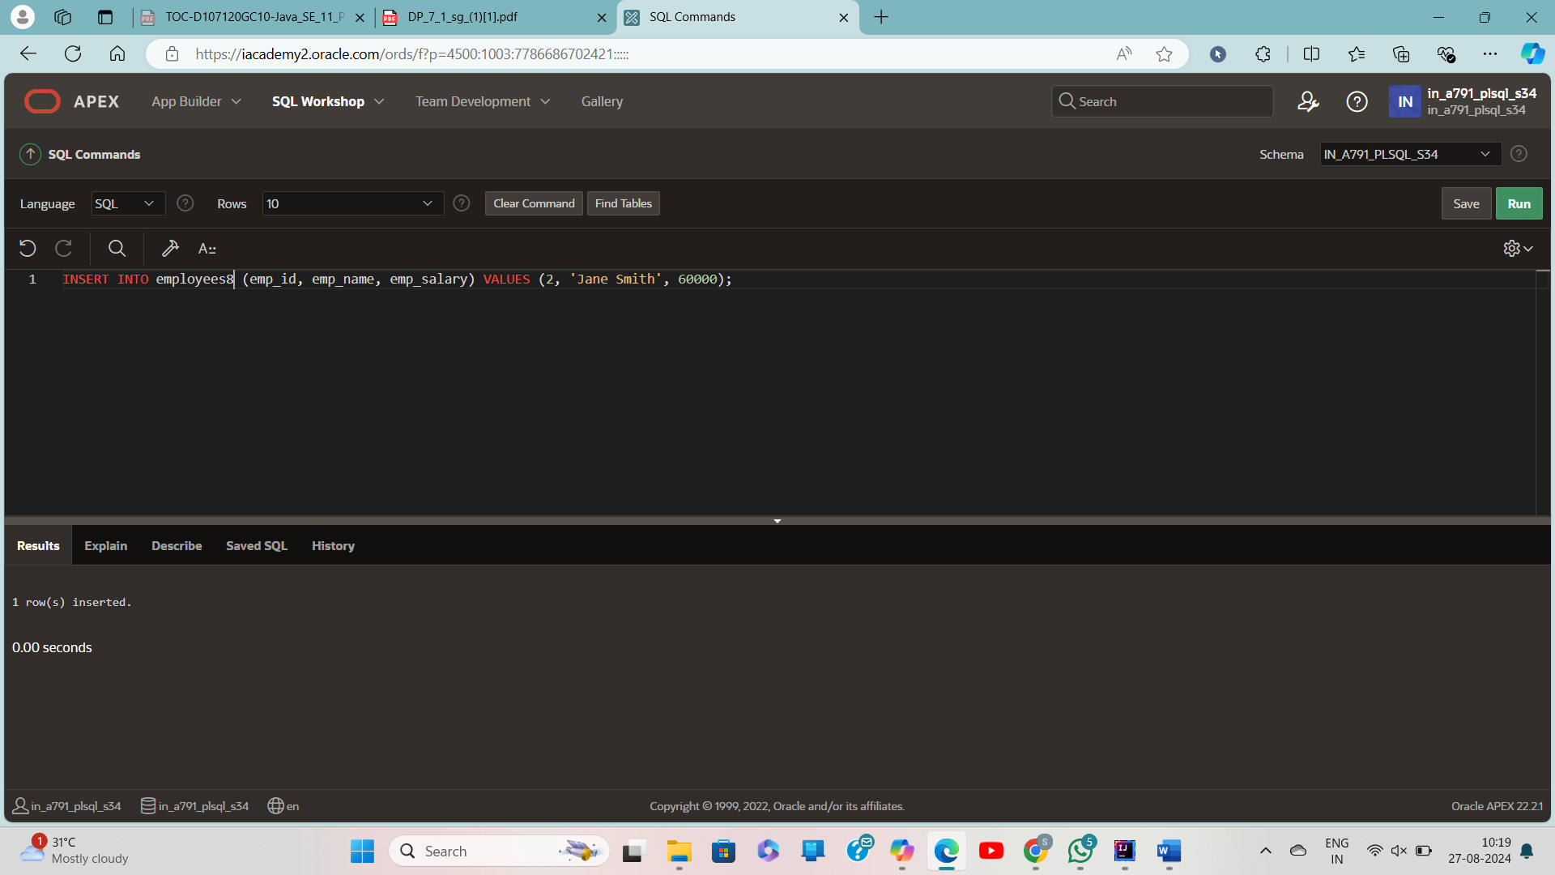

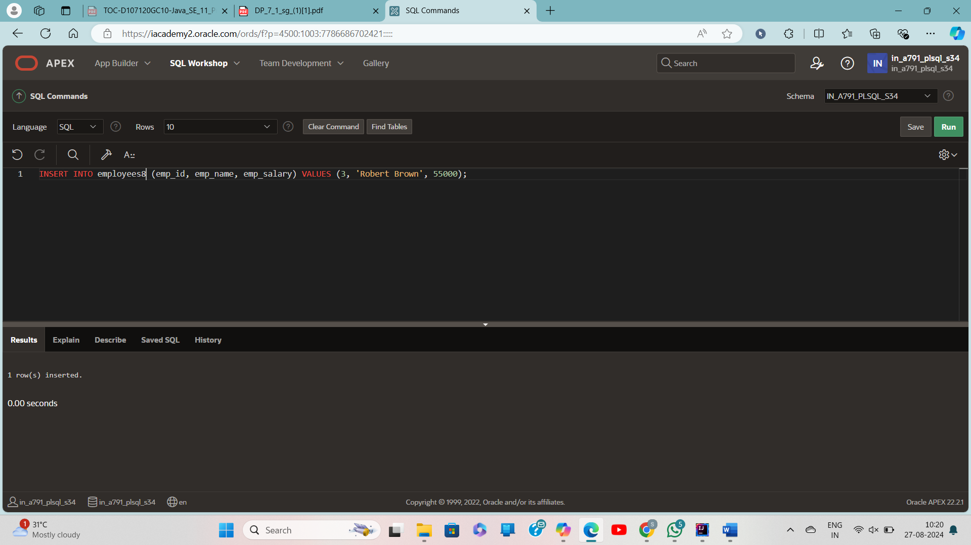

INSERT INTO employees (emp_id, emp_name, emp_salary) VALUES (1, 'John Doe', 50000);

INSERT INTO employees (emp_id, emp_name, emp_salary) VALUES (2, 'Jane Smith', 60000);

INSERT INTO employees (emp_id, emp_name, emp_salary) VALUES (3, 'Robert Brown', 55000);

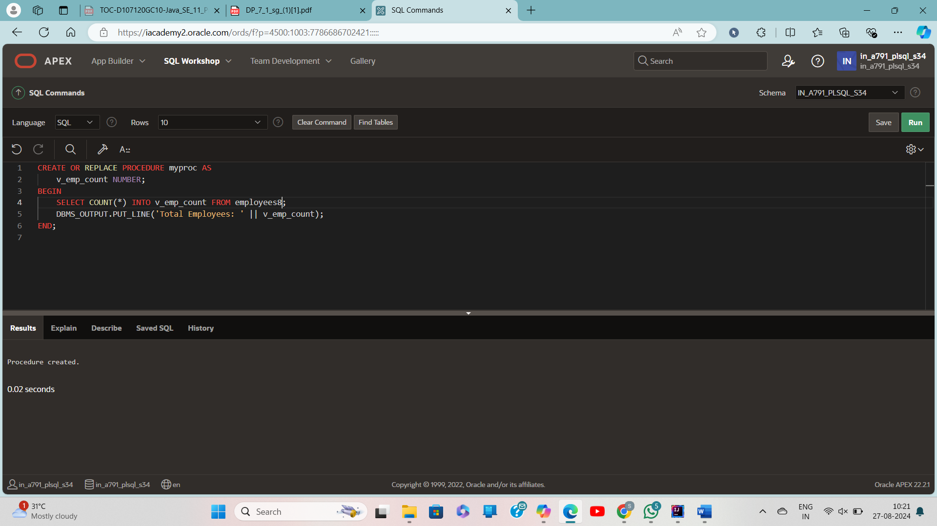

CREATE OR REPLACE PROCEDURE myproc AS

v_emp_count NUMBER;

BEGIN

SELECT COUNT(*) INTO v_emp_count FROM employees8;

DBMS_OUTPUT.PUT_LINE('Total Employees: ' || v_emp_count);

END;

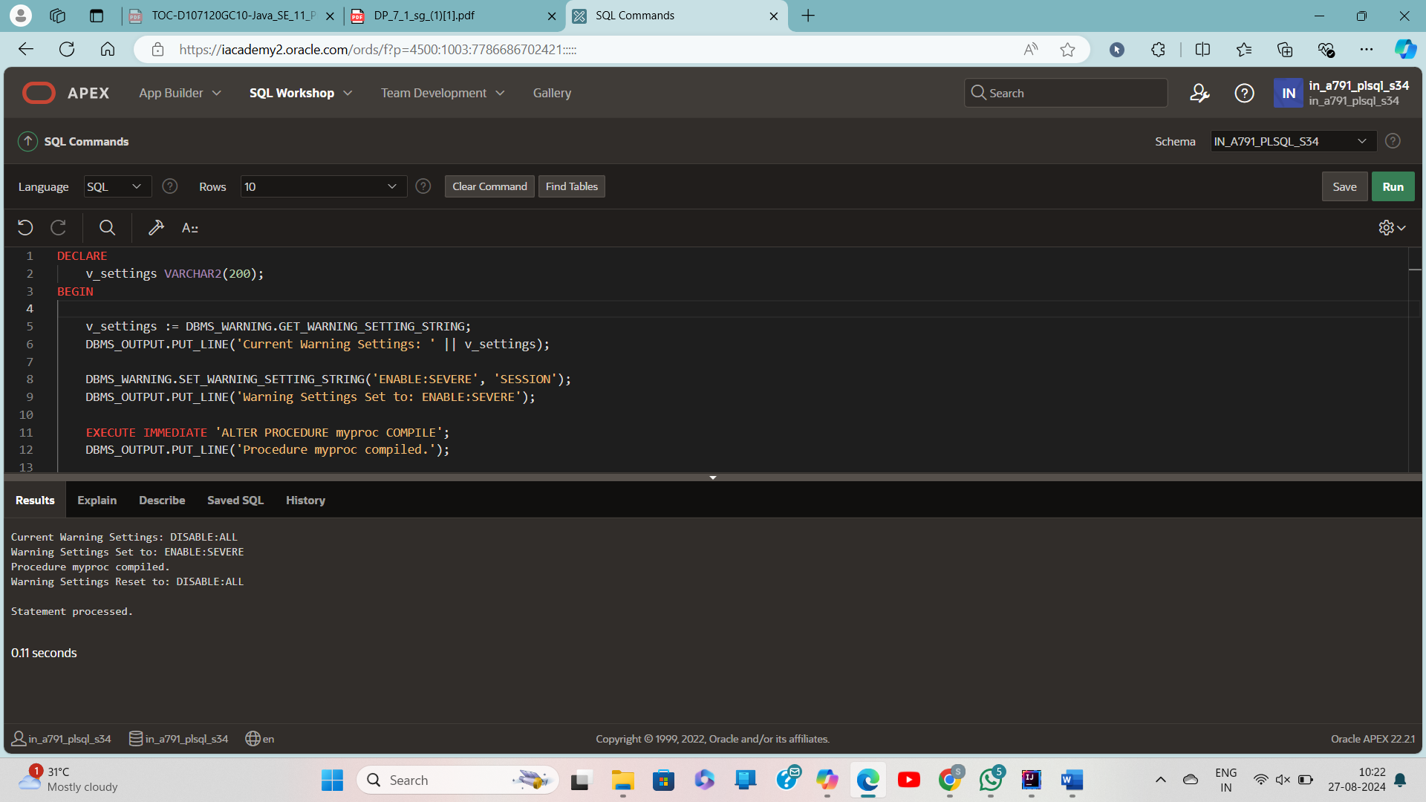

DECLARE

v_settings VARCHAR2(200);

BEGIN

v_settings := DBMS_WARNING.GET_WARNING_SETTING_STRING;

DBMS_OUTPUT.PUT_LINE('Current Warning Settings: ' || v_settings);

DBMS_WARNING.SET_WARNING_SETTING_STRING('ENABLE:SEVERE', 'SESSION');

DBMS_OUTPUT.PUT_LINE('Warning Settings Set to: ENABLE:SEVERE');

EXECUTE IMMEDIATE 'ALTER PROCEDURE myproc COMPILE';

DBMS_OUTPUT.PUT_LINE('Procedure myproc compiled.');

DBMS_WARNING.SET_WARNING_SETTING_STRING(v_settings, 'SESSION');

DBMS_OUTPUT.PUT_LINE('Warning Settings Reset to: ' || v_settings);

END;

/